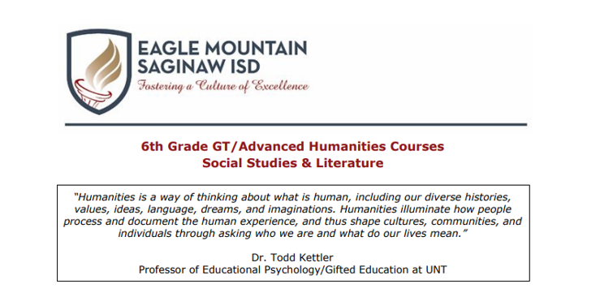 Dear Parent or Guardian,
Your child has the opportunity to enroll in several new courses in sixth grade. In addition
to the regular and Advanced courses offered in 6th grade Social Studies and ELAR, your
child is eligible to enroll in the Humanities courses in 6th grade Social Studies and ELAR.
Please discuss the information below to make the best course registration decision for
your family.

In GT Humanities Social Studies, students develop intellectual character by pursuing a
conceptual question for each unit in order to engage in complex thinking about
advanced content. These units entail independent research, collaborative problem
solving, and a significant amount of written and oral communication to produce
real-world products for authentic audiences.

In GT Humanities Literature, students develop intellectual character by pursuing the
same conceptual question as the GT Humanities Social Studies course for each unit in
order to engage in complex thinking about advanced content. These units entail
independent research, collaborative problem solving, and a significant amount of
reading to produce real-world products for authentic audiences.

